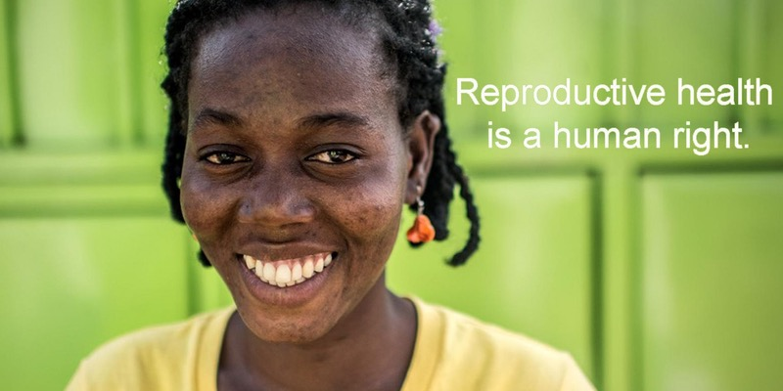

Transforming ‘work’: Linking Care, Public Services and Women’s Economic Empowerment
Location: TBC
Date: Monday 13th March
Time: 6.15PM-8.15PM

This side event will bring together young women, researchers, labour rights, SRHR and feminist organizations and government representatives to talk about care dynamics, implications for women’s economic participation and Gender Responsive Public Services as a pathway towards women’s economic rights.

Proposed speakers include:
- Young woman from ActionAid program from SA/Ghana
- Institute of Development Studies, Sussex, UK (IDS)
- Insitute of Social Studies Trust, India (ISST)
- BRAC Regional Evaluation Unit, Uganda (BRAC REU)
- International Planned Parenthood Federation (IPPF)
- Association for Women’s Rights in Development (AWID)
- Public Services International (PSI)
- Counting Women’s Work project (Gretchen Donehower, UC Berkeley)

Audience: Government missions and CSOs

Violence against women and the achievement of economic empowerment
Location: UNHQ Express Bar - level 3
Date: Wednesday 15th March, 2017
Time: 8:15AM - 9:30AM

At this side event the panel will examine the implementation of national policies that aim to prevent and eliminate violence against women and girls. Countries will discuss their progress against Sustainable Development Goal 5 on Gender Equality and women's empowerment and eliminating all forms of violence against all women and girls in both public and private spheres

Speakers include:
- Minister of Gender and Poverty Eradication, Fiji
- Minister of Gender Equality and Child Welfare, Republic of Namibia
- Special Rapporteur on violence against women
- Minister of Gender, Belgium
- IPPF/WHR expert

Audience: Government missions and CSOs
Abortion and birth control: universal rights and a condition to women’s autonomy
Location: UNHQ, Conference Room A
Date: Wednesday 15th March, 2017
Time: 1PM - 2:30PM

This side event will focus on the link between women’s empowerment and the equality of women in the world of work and unimpeded access to legal and affordable abortion, contraception and safe reproductive health services. The panel will explore the work of international bodies and feminist associations on the on the ground and call for international mobilization for the recognition of the universal right of women to access abortion and contraception; a major condition for their economic autonomy.

Speakers include:
- Laurence Rossignol, Minister of Families, Rights of Women and Children, France
- Françoise Morvan, President of the French Coordination for the European Lobby (CLEF)
- Babatunde Osotimehin, Director of the United Nations Population Fund (UNFPA)
- Patricia Da Silva, International IPPF Advocacy Officer
- Rebecca Chalker, feminist activist, author, USA
- Barbara Nowacka, Save the Women Committee, Poland
- A representative of a feminist association, or feminist leader, Latin America

Audience: CSOs and private sector representatives

A rollback on women’s rights? The Impact of the Global Gag Rule – IPPF CO
Location: McCann Health, 622 3rd Avenue
Date: Wednesday 15th March, 2017
Time: 6.30PM-9PM (with drinks and refreshments)

This side event will bring together a diverse range of CSO representatives to explore the fundamental importance of access to sexual and reproductive health for women’s rights all over the world. The panel will examine the potentially devastating impact of the US Mexico City Policy or ‘Global Gag Rule’ on women in low income countries and the knock on effects on economic empowerment, gender equality, access to safe abortion, gender-based violence and sustainable development.

The panel will consist of speakers from:
- Anne Quesney, Senior Women’s Rights Advocacy Adviser, ActionAid UK
- Kasia Staszewska, Women's Rights Programme Manager, Amnesty International UK
- Preethi Sundaram, Advocacy Adviser, International Planned Parenthood Federation (IPPF)
- Andrew Schirmer, President, McCann Health
- Latanya Mapp-Frett, Board of Directors, Oxfam America
- Fionna Smyth, Senior Advocacy Adviser on Sustainable Development Goals, UN Women

Audience: CSOs and private sector representatives

